**Lab-07**

**Instructions:**

* Indent your code properly.
* Use meaningful variable names. Follow the naming conventions.
* Use meaningful prompt lines/labels for all input/output that is done by your programs.
* You are not allowed to discuss your problems with your fellows. If you feel any problem in understanding then you may ask your teacher or TA.

**Task 1:**

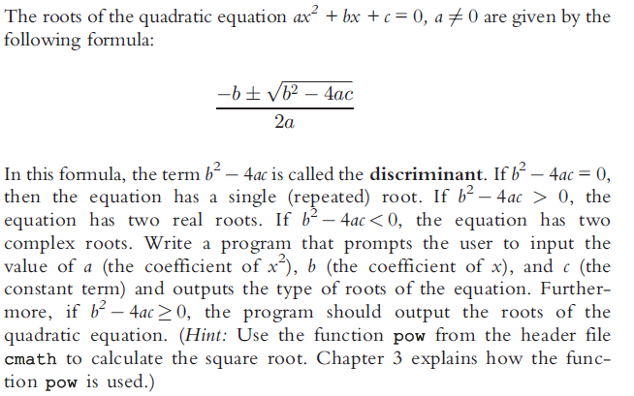

**Task 2**

Write a program that takes size from user a displays the following pattern:

**Sample Run 1:**

Enter Size: 3

**Output:**

1

1 2

1 2 3

**Sample Run 2:**

Enter Size: 5

**Output:**

1

1 2

1 2 3

1 2 3 4

1 2 3 4 5

**Task 3**

Write a program that takes size from user a displays the following pattern:

**Sample Run 1:**

Enter Size: 3

**Output:**

1 2 3

1 2

1

**Sample Run 2:**

Enter Size: 5

**Output:**

1 2 3 4 5

1 2 3 4

1 2 3

1 2

1

**Task 4**

Write a program that takes size "n" from user and displays the following pattern.

**Sample Run 1:**

Enter Size: 5

* * * * *

* * * *

* * *

* *

*

**Task 5**

Write a program that takes size "n" from user and displays the following pattern.

**Sample Run 1:**

Enter Size: 10

**\*\*\*\*\*\*\*\*\*\***

**\*\*\*\*\*\*\*\*\***

**\*\*\*\*\*\*\*\***

**\*\*\*\*\*\*\***

**\*\*\*\*\*\***

**\*\*\*\*\***

**\*\*\*\***

**\*\*\***

**\*\***

**\***